Director Recruitment Briefing

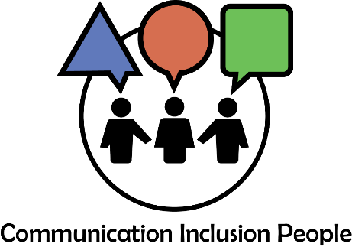

Do you want to help create communication equality in Scotland?

Hundreds of thousands of people in Scotland experience communication inequality every day, everywhere.

People may be too tired or unwell to take information in. They may not be able to see or hear or use speech or writing to understand or express themselves. They may not have, or be able to use, a computer or phone.
Organisations often expect people to communicate in ways which are not possible or easy for them. For example, they may not give people time to respond to enquiries in the way they choose. This can result in people facing a penalty or exclusion from services and opportunities. Their human rights are eroded.

Introduction to Communication Inclusion People

Communication Inclusion People is a small growing community interest company based in Edinburgh. It was set up by Kim Hartley Kean and Amanda Bennett, two highly regarded specialists in the field of inclusive communication. They are both Speech and Language Therapists.

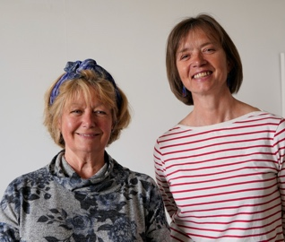

Find out more about us at www.communicationinclusionpeople.com.

Our mission

We are passionate about working with others to create communication equality through universal adoption of inclusive communication good practice.

Our core values

- Communication inclusion
We communicate with people in the ways they prefer.

- Human Rights and Equality
We do everything we can to uphold

- Respect
We treat everyone who we have contact with with respect.

Background

We were incorporated in 2020. We started trading in Autumn 2021.

Our biggest piece of work so far has been a national project for Public Health Scotland. We have also completed several smaller projects. More information is available on our website at www.communicationinclusionpeople.com

Scottish Government and other public, private and third sector organisations increasingly recognise the importance of inclusive communication. We are early entrants to a growing market for our services. Regulation and government support for inclusive communication across Sctland’s public sector is expected soon.

Do you want to join us?

We are looking to appoint two new members to our Board to help us develop the business.

Say “yes” if you want to:

Be involved in a new developing social enterprise with a lot of promise.

Take the opportunity to make change for good.

Be part of a new initiative to promote communication equality in Scotland.

Be a ‘change maker’ as we work to remove the barriers faced by people who communicate differently to the majority.

If you have the knowledge, skills or experience in one or more of the following areas we’d love to hear from you:

- Business development
- Marketing and promotion
- Equality, diversity and inclusion
- Contracting and negotiating with decision makers
- Accounting, Human Resources, and People Management
- Financial management, measuring goals, objectives and success

Present Board of Directors membership

Amanda Bennett
Speech and Language Therapist
Co Founder

Kim Hartley Kean
Speech and Language Therapist
Co Founder

Paul J Ralph, FRSA
Professional and Lived Experience of inclusive communication

Board members responsibilities

As a Board member you will be jointly responsible for:

- Helping the business to be as successful as possible.
- Making sure we follow our aims and values and use money wisely.
- Checking we follow the law on financial management, people management, data protection and other governance.
- Advising on, contributing to and agreeing strategic direction, operational plans and policies.
- Promoting and championing inclusive communication and Communication Inclusion People as often and in as many ways as possible.
Individual Directors may take responsibility for specific tasks.

Directors commitment

We ask Directors to commit to:

- A minimum 12-month term.
- Take part in induction activities on inclusive communication and our company.
- Actively participate in quarterly meetings. These will be held in Edinburgh if attended in person. Directors can attend remotely if necessary. These will typically be two to three hours long.
- Respond to requests for action in between meetings. We will always communicate with people in ways they find easiest as well as giving people a reasonable amount of time to respond to any requests.
- Champion inclusive communication and Communication Inclusion People in as many ways as possible.

- Follow inclusive communication good practice in their own communication.

Support for Directors

We offer Directors:

- Expenses to cover communication support
- Travel expenses for public transport where possible
- Induction training on our approach to Inclusive communication and our business

Contact us

If you have any questions please contact us.

If you are interested in joining us please contact Amanda or Kim.

Tell us your
- name
- preferred contact details
- relevant experience
- why you are interested in joining us.
- how and when you would like us to contact you back.

Let us have it in the form you find easiest e.g. written, audio or video.

Contact us in the way you prefer.

info@communicationinclusionpeople.com
07916 212 831
07916 212 831
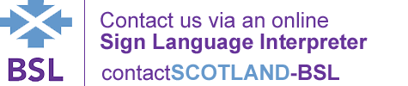

Information sheet written on 16 May 2023

